***Apocalypse Alphagram* FPS Investigation**

So in the initial phase, game FPS was around 20 only, which is very low.

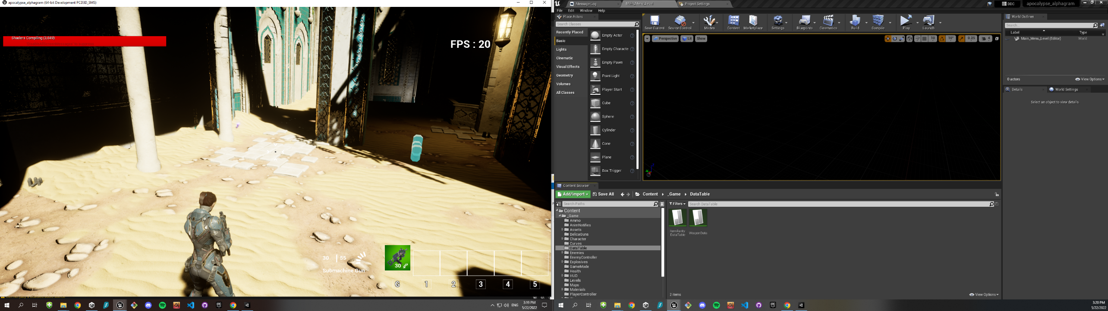

The suspicious parameters for this problem are

* Physical Interaction
* Animations
* Engine Scalability Settings

Physical Interaction:

All the collusion physics are mandatory for the gameplay of this project. So we cant replace those

Particle System:

An enemy have 100 points of health , and a weapon have two parameters for causing damage. Initially It was 1 for body shot and 5 for head shot , for which, character had to fire a lot.



For the situation:

Pros: It makes the game more intense

Cons: More firing means more particles are spawning ( muzzle flash, smoke beam, bullet shells)

So , I increased the damage amount to 10 , 15



After that , the FPS increased Dramatically

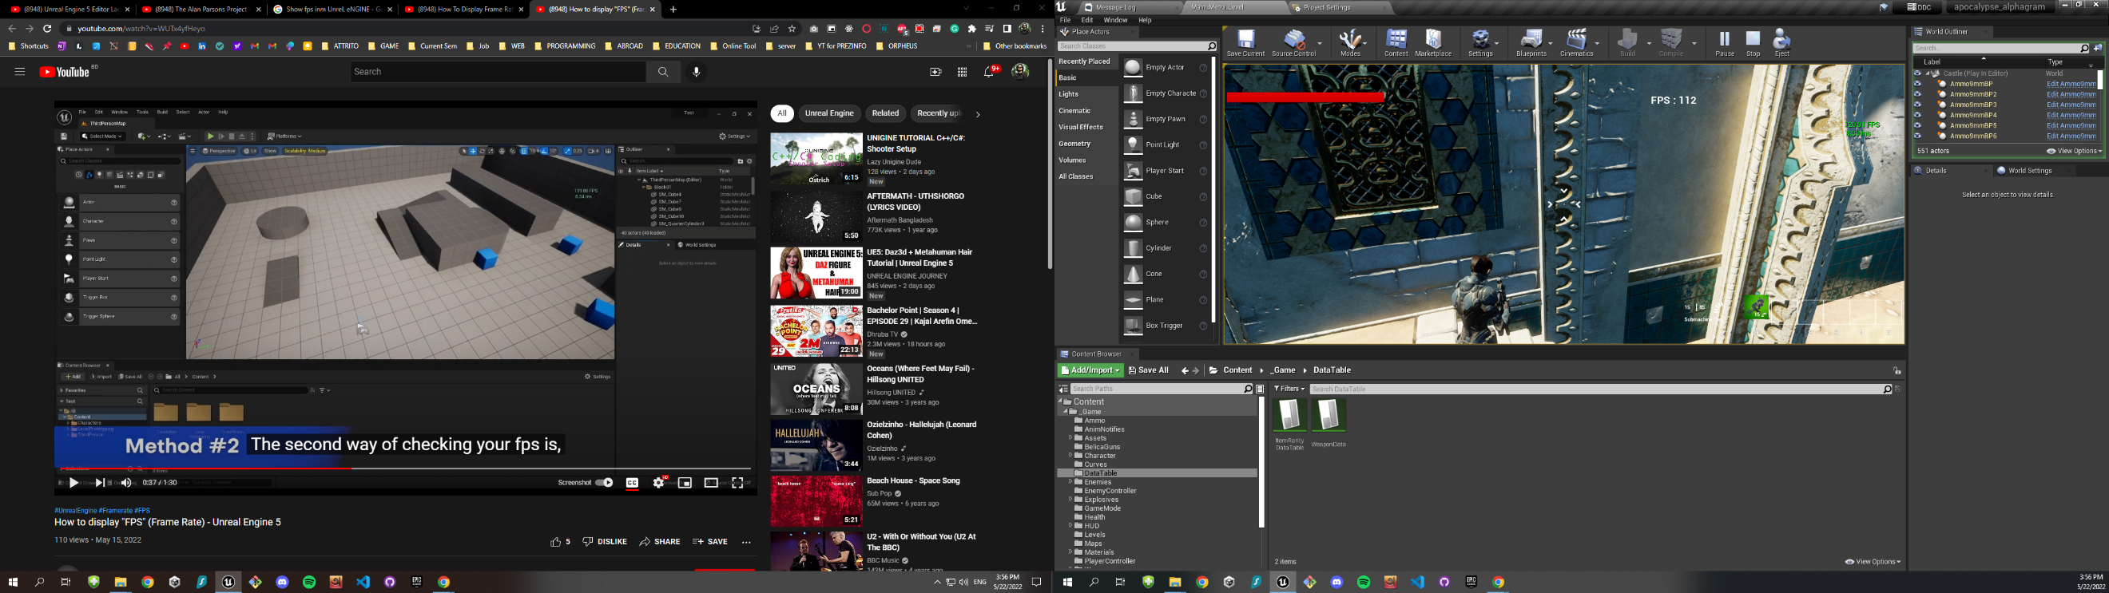

**Engine Scalability Settings:**

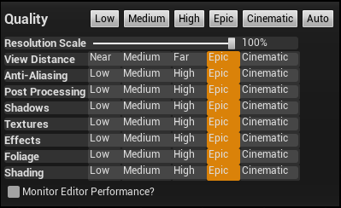

By default, all the rendering settings are in Epic state. If we set the values low for Shadow, Textures and Shading, it increases the frame rate too.

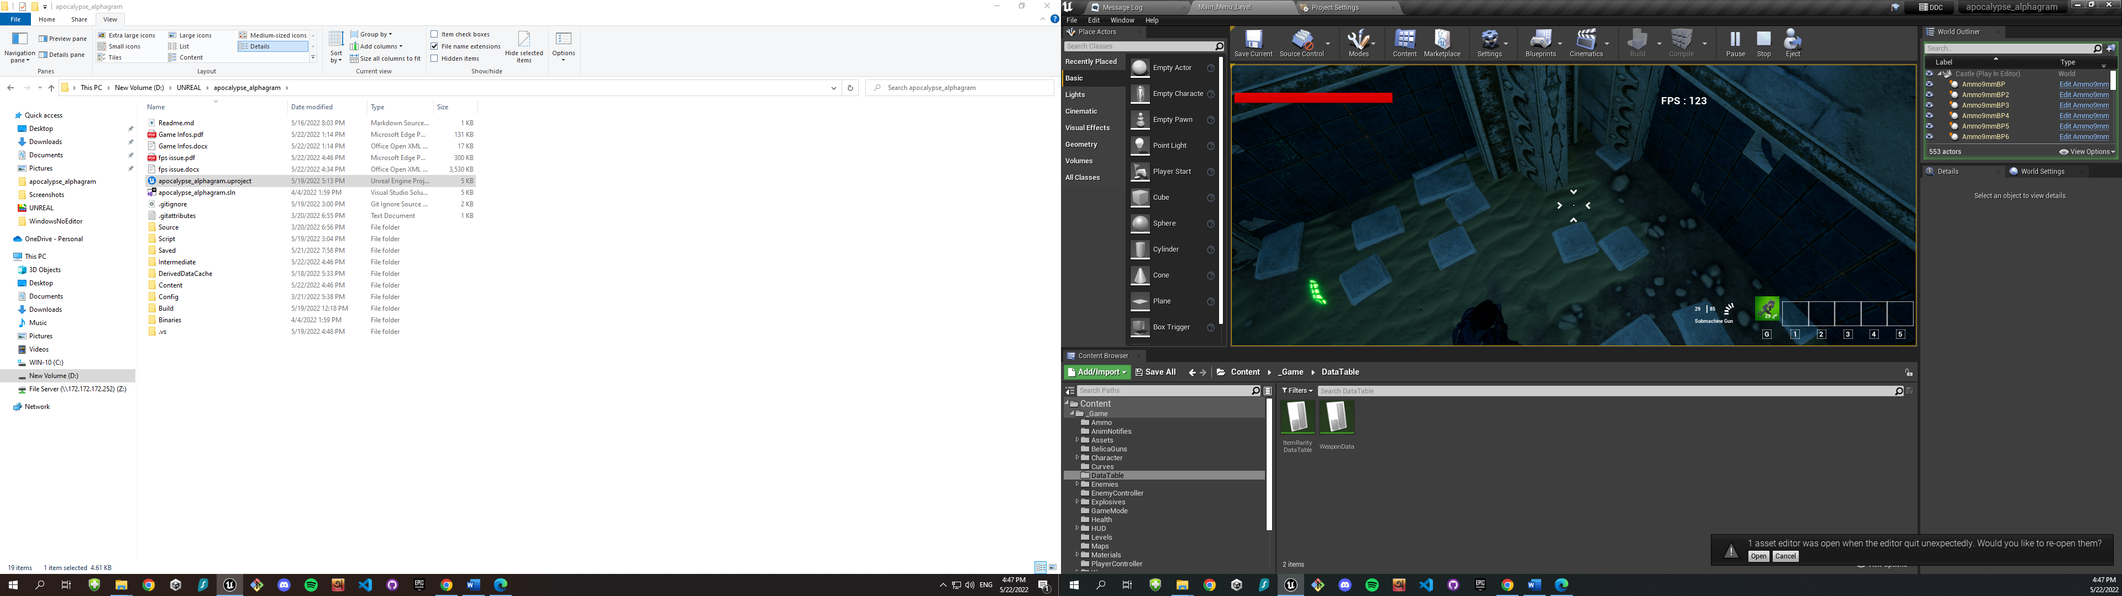

So , the FPS issue is being triggered by

* Particle System
* Heavy Assets in the game

Besides, there are some plugins in unreal Engine , which may responsible for this. As those are making errors while building and export the project , I disabled many of those.